Project Name |  | Confidentiality Level
Contract Software Requirements Project |  | For Recipients’ Reference Only
Project ID | Version | Document Code
Group 3 | 1.0

Contract Software Requirements Requirements Specification



Copyright © Ruankosoft Technologies(Shenzhen), Co., Ltd.
. All Rights Reserved
Revision Record
Date | Revision Version | CR ID /Defect ID | Sec No. | Change Description | Author
30.05.2017 | 1.0 | 15309003 |  | Define the requirements of the project | Shin Kiho

Content
1 Introduction................................................................................................................6
1.1Purpose............................................................................................................................................6
1.2Scope...............................................................................................................................................6

2 GeneralDescription....................................................................................................6
2.1Software perspective……………………………………………………………………………...6
2.2 Software function ..........................................................................................................................6
2.3 User characteristics........................................................................................................................7
2.4 Assumptions &Dependencies........................................................................................................7

3 Specific Requirements ............................................................................................ 8
3.1 System use case...............................................................................................................………….8
3.2Register.............. .....................................................................................................……………….9
3.3 Login ..............................................................................................................................................10
3.3.1 Login........................................................................................................................................10
3.3.2Logout.......................................................................................................................................10
3.4 Contract management.....................................................................................................................10
3.4.1 Draft Contract......................................................................................................................... 11
3.4.2 Countersign Contract...............................................................................................................13
3.4.3 Finalize Contract.... ................................................................................................................ 14
3.4.4 Approve Contract ....................................................................................................................15
3.4.5 Sign Contract...........................................................................................................................16
3.5Query.................................................................................................................................................17
3.5.1 Query Contract Info ................ .................................................................................................17
3.5.2 Query Contract Process.............................................................................................................17
3.6 Fundamental data management ..................................................................................................18
3.6.1 Contract Info........................................................................................................................... .18
3.6.2 Customer Info.................................………………………………………..…...................... .18
3.7 System management....................................................................................................................... 18
3.7.1 Assign Contract .......................................................................................................................18
3.7.2 Authorize..................................................................................................................................20
3.7.3 System Log...............................................................................................................................20
3.8 Data Information.............................................................................................................................20

4 Interface Requirements............................................................................................20
4.1 User Interface ..............................................................................................................................20
4.2 Software Interface ........................................................................................................................20
4.3 Communication Interface............ ................................................................................................20
5 Overall Design Constraints. ....................................................................................21
5.1 Hardware Limitations..................................................................................................................21
5.2 Technology Limitations...............................................................................................................21

6 Software Quality Attributes.....................................................................................21
6.1 Reliability....................................................................................................................................21
6.2 Usability .....................................................................................................................................21

7 Requirements Classification....................................................................................22

1 Introduction
1.1 Purpose
This manual describes user requirements for functions and performance of the Contract
Management System. The intended audience includes: Users, Project administrators, Testers,
Designers, Developers. The manual focuses on function requirements of Contract Management System; clarifies mandatory functions, performance and interfaces of the developed software; assists system analysts and software developers in user demand-orientation.
1.2 Scope
This manual describes function requirements, data information, interface requirements of System.
2 General Description
2.1 Software perspective
This software is a web application. The system uses the b/s (Browser/Server) structure, Users only need to access the website through the browser. The operation of the server side need to configure the application environment(JDK1.6), this system need Installation of MySQL database.
2.2 Software function
System function structure:

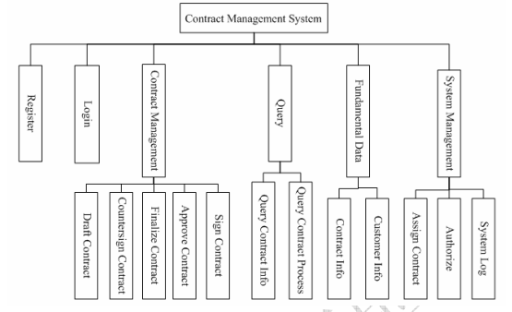

System is divided into 6 modules:
Register, Login, Contract Management, Query, Fundamental Data Management, System
Management.

2.3 User characteristics
1, administrator: focuses on the management of system, Has the supreme right to maintain normal operation of the system.
2, operator: focuses on the management of the contract process.
3, new user: has no right at all, waiting for the contract administrator to configure permission.

2.4 Assumptions & Dependencies
The development language of system is Java. Using MySQL for data storage, The system uses the b/s (Browser/Server)structure, Users only need to access the website through the browser.

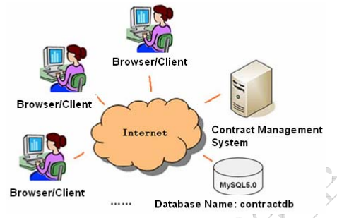

3 Specific Requirements
3.1 System use case
When the user is registered, become the system new user, he can only use the contract management system after the administrator assign permission for him. Contract operator can manage contract operation process; Administrator can manage system, assign the contract, follows the contract process and status and so on.
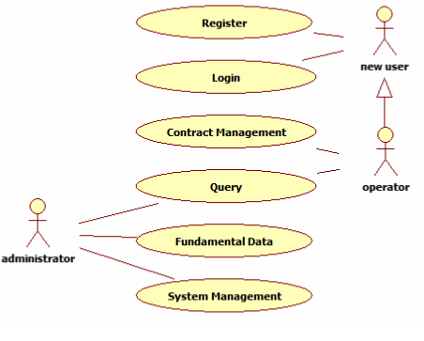

3.2 Register
Fill in register information: user name and password in register page, confirm the password
( consistent with the password), then register.
The required registration information cannot be empty, the tip information is given when the registration failed, jump to the login page when registration successful.
The register page is as follow:
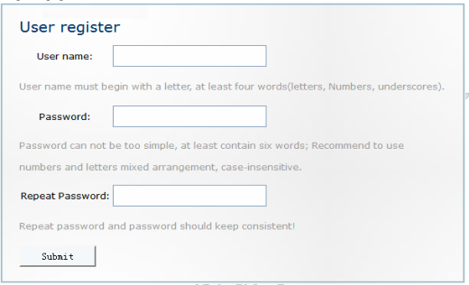

3.3 Login

3.3.1 Login
Fill in the user name, password in the login page, click “Login” button to log in.
The required login information cannot be empty, the tip information is given when login failed, jump to the new user page when login successful, and display the information of user name.
The login page is as follow:
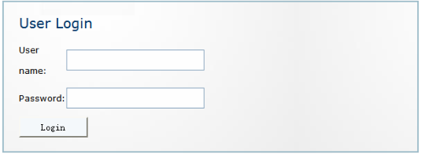

3.3.2 Logout
The user who already logged in, click “logout” link in the new user page, clear the user’s login status, return to the login page.

3.4 Contract management
1. Introduction
After the contract operator log in, can draft a contract, which can based on the assigned, and carry on the corresponding countersignature, approval and sign operations.

2. Contract management use case
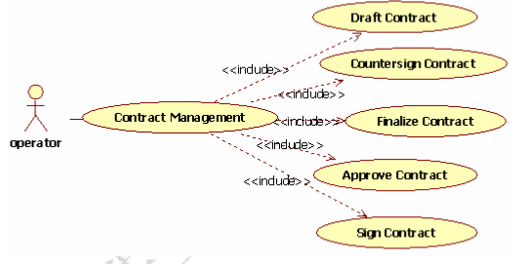

3.4.1 Draft Contract

1. Introduction
User in operator role has the right to draft contract. Drafting can be made after operator logs on system.
Write content of information named contract name, start time, end time, content(required) and customer on drafting page.
After drafting is successfully made, the status of contract turns to Draft, which is the sign for the administrator to distribute.
the status of contract:
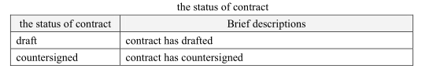
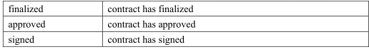

The daft contract page is as follow:
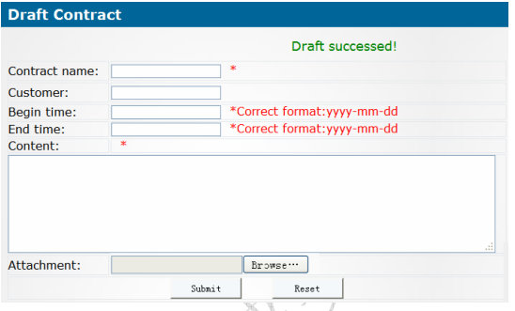

2. Input
Write following data on page.
Contract name, start time, end time, content(required), customer.
3. Process
(1) The verification data is required. The format of Start time and End time should satisfy the requirement. If the content is not completed or the date format is wrong, prompting message shall be given.
(2) Save contract data in contract, and save its status data in contract state at the same time. The status is Draft. Return contract drafting page to inform the user. Keep the previous drafting contract data in table.
4. Output
(1) Drafting succeeded
Prompt user of the message “Drafting Succeeded!” on page.
(2) Drafting failed
① Prompt user of the message “Contract data is required. Incorrect date format.”
② Prompt user of the message “Drafting failure!”
(3) If system error occurs, jump to exception page.

3.4.2 Countersign Contract
1. Introduction
The countersigner checks the list of contracts to be countersigned; choose one contract content to check, and input the countersignature opinions and then countersign.
The contract list page to be countersigned is as follow:
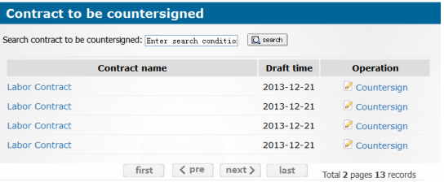

The counter signature page is as follow:
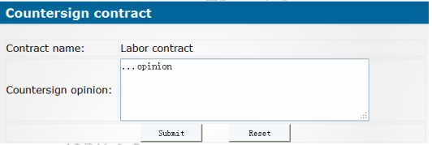

2.Input
id of contract
id of user
Countersignature opinion
3.Process
(1) data validation
The inputted countersignature opinion cannot be empty.
(2) dispose process
Enquire list information of contracts to be countersigned, and display on contract list to be countersigned page.
Preview the contract
Enquire the details contract information; pass to the detailed page of contract to display.
Countersign the contract
Enquire the contract information to be countersigned, pass to the countersignature contract page to display.
According to the countersignature page to fill in the countersigned opinion, update the information of the contract process.
If all the countersigner have Countersigned, then save the completed information status of countersignature contract.
4. Output
(1) Contract detail.
(2) Contract to be countersigned.
(3) Updated process information.
(4) Contract status information.
(5) List of contracts to be countersigned.

3.4.3 Finalize Contract
1. Introduction
Drafter check the list of contracts to be finalized, choose one contract content to check it’s countersignature opinion, and amend the contract to finalize.
2. Input
conId: id of contract to be finalized.
userId: id of the drafter.
content: contract content to be updated.
3. Process
(1) data validation
The inputted countersignature content cannot be empty.
(2) dispose process
Enquire list information of contracts to be finalized, and display on contract list to be finalized page.
Enquire countersignature opinion
Enquire the countersignature information of contract, pass to the counter signure opinion page to display.
Finalize contract
Enquire the contract information to be finalized, pass to finalization page to display.
Get contract data to be updated, and update contract information.
After the contract is finalized, save the completed information status of finalized.
4. Output
(1) Countersignature opinion of contract.
(2) Contract to be finalized.
(3) Updated contract information.
(4) Contract status information.
(5) List of contracts to be finalized.
3.4.4 Approve Contract
1. Introduction
Approver checks the list of approved contract; choose one contract content to review, and fill in the approval opinion to approve.

2. Input
conId: id of contract to be approved.
userId: id of the approver.
content: approval opinion.
approved operation: pass or refuse.
3. Processing
(1) data validation
The inputted approval opinion cannot be empty.
(2) dispose process
Enquire list information of contract to be approved, and display on contract list to be approved page.
Enquire the contract information to be approved, pass to the approval page to display.
Based on the approved operation and approval opinion, update the information of the contract process.
If all approvers have approved and passed, then save the completed information status of approval contract.
4. Output
(1) Contract details.
(2) Contract to be approved.
(3) Updated process information.
(4) Contract status information.
(5) List of contracts to be approved.

3.4.5 Sign Contract
1. Introduction
after the contract is approved, when the assigned signer logins the system and views contract list to be Signed, he can select a contract and open it to review the content, and then, perform the signature operation to a specific contract.

2 .Input
conId: id of contract to be signed.
userId: id of the signer.
content: signature opinion.
3. Process
(1) data validation
The inputted signature information cannot be empty.
(2) dispose process
Enquire list information of contract to be signed, and display on contract list to be signed page.
Enquire contract information to be singed, pass to the sign page to display.
According to the signed information, save the completed information status of the signed contract.
4. Output
(1) Contract details.
(2) Contract to be signed.
(3) Updated process information.
(4) Contract status information.
(5) List of contracts to be signed.

3.5 Query
The administrator can enquire and search the basic information of contract, and follows the contract process and status.
3.5.1 Query Contract Info
According to the contract numbers and names, enquire the contract.
3.5.2 Query Contract Process
According to the status of contract enquire the contract.

3.6 Fundamental data management
Administrator can manage the contract information and customer information.
3.6.1 Contract Info
The contract information to add, enquire, modify and delete operations.
Add contract corresponds to draft contract module; Modify contract corresponds to finalize contract module.
3.6.2 Customer Info
The customer information to add, enquire, modify and delete operations.

3.7 System management
Administrator can assign the contract, authorization management and log management and so on.

3.7.1 Assign Contract
1. Introduction
Administrator chooss the contract to be assigned which the status is “draft”, Assign people who involves in countersignature, approval and signment. so as to complete the operation of assigning.

The contract list page to be assigned is as follow:

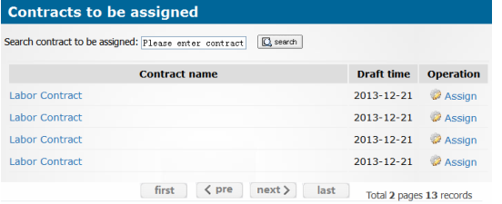
The assignment page is as follow:
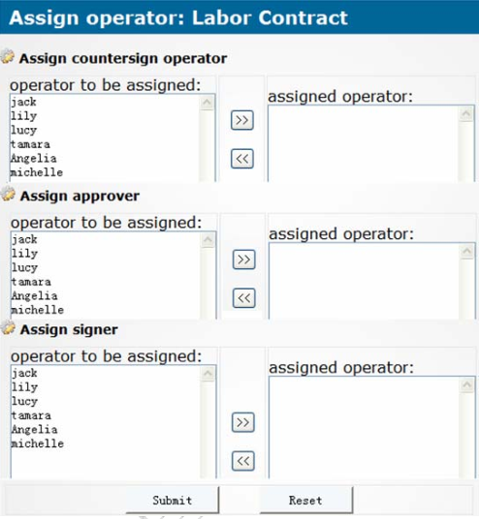
2. Input
conId: id of contract to be assigned.
user ids of designated person which take part in countersign, approval, and signment.
3. Processing
(1) data validation
All the people who take responsibilities for countersign, approval, and signment need to be assigned.
(2) dispose process
Enquire list information of contract to be assigned, and display on contract list to be assigned page.
Enquire the contract information to be assigned, pass to the assign page to display.
Save the assignment information of the contract operation process.
4. Output
(1) Contract to be assigned.
(2) List of people who may be assigned with contracts.
(3) Information of contract assigned.
(4) List of contract to be assigned.
3.7.2 Authorize
Authorization management includs user management, role management, function operation, permission configuration and permission validation. The administrator can assign and manage the permission.
3.7.3 System Log
The user's operation has a corresponding logging in the system, the administrator can manage log.

3.8 Data Information
Describe the data information of the system.

4 Interface Requirements
4.1 User Interface
For most users, screens are larger than 17 inches, the resolution is 1024x768 (it is 600x800 in a few cases), and software interfaces should adapt to the screen dimension.
4.2 Software Interface
This is a web application program with MySQL5.x.
4.3 Communication Interface
To communicate using the HTTP protocol.

5 Overall Design Constraints
5.1 Hardware Limitations
Minimum configuration on a computer:
CPU: 1 GHZ
Memory: 128 MB

5.2 Technology Limitations
File format: text mode file or binary mode file format.
Coding standard: Java Coding standard

6 Software Quality Attributes
6.1 Reliability
Adaptability: New services and functions can be easily added to the system on the basis of its basic functions, without affecting the architecture of the original website system. The system can adapt to browsers of multiple versions.
Fault tolerance: In the case of system crashes, memory insufficient, it will not cause the system failure and the system can normally power off & restart.
Recoverability: The system should be able to run properly after a fault is resolved.

6.2 Usability
Usability: The interface design should be reasonable, concentrating system functions and making the system user-friendly. The system should block users' illegal input data or operations, provide wizards and notes for complex processing, and provide users with handy help information.

7 Requirements Classification
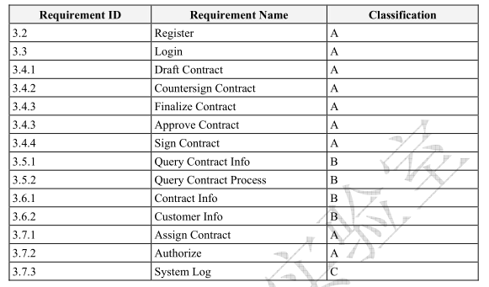
Importance of requirements is classified as following:
A. Mandatory: absolutely essential features, without which the product development will be canceled.
B. Important: unessential features that may affect the viability of the product.
C. Nice to have: desired features, the absence of which will not affect the product viability.

